­­

JUMP 4 ENDURANCE RHYMES

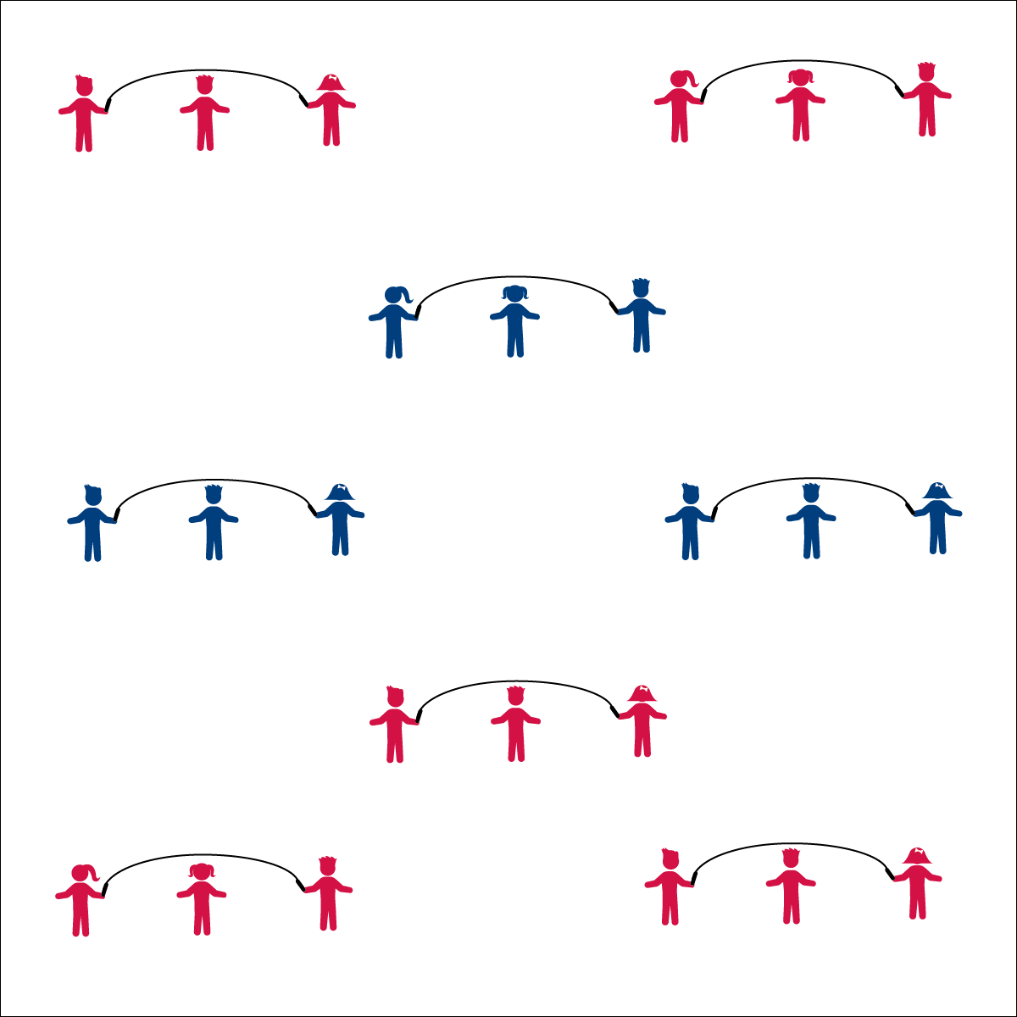

**Activity Procedures:**

1. Let’s see how long we can jump our ropes using the endurance rhymes listed below.
2. To start, begin jumping your rope while calling out the rhyme. Keep counting (or saying the alphabet) until you make a jump rope mistake and have to stop.
3. How many jumps can you make in a row with no mistakes?
4. After you master each rhyme, work to try and add all of the different jump rope tricks that you know.

**Endurance Rhymes:**

* I can jump. I can hop. How many jumps before I stop? 1, 2, 3, 4...
* Up, and up. Down, and down. Jump and make the world go ‘round! 1, 2, 3, 4...
* Pick a fruit. Pick a veggie. How many picked before I’m ready? 1, 2, 3, 4...
* ABCs and vegetable goop. What letters land in the vegetable soup? A, B, C, D...

**Equipment:**

* 1 long jump rope per 3 players
* 1 short jump rope per player

**Set-Up:**

1. 3 players at a rope.
2. Spread out in general space with enough space to turn the rope safely.
3. Get your jump ropes ready!

*Looking for more physical education and activity ideas?*

**Visit** [**OPENPhysEd.org**](http://www.openphysed.org/) **and find free activity plans and resources.**

**What is OPEN?** OPEN is a national grassroots organization of teachers helping teachers working to provide physical educators and activity leaders free curriculum tools and outstanding professional development experiences. OPEN is a public service of [BSN Sports](http://www.bsnsports.com/) and [US Games](http://www.usgames.com/) with a network of 60 national trainers providing curriculum support and professional development experiences to teachers around the world. More than 43,000 teachers have downloaded lesson plans and resources that have enhanced the educational experience of 22 million students.

* **Focus on Fruit:** Eating a fresh apple (including the skin!) is one of the best things you can do with your teeth on any given day. Eating the skin with the rest of the apple gives you twice as much fiber when compared to peeled apple slices. Not to mention all of the other essential nutrients that are found mostly in the skin. Eat up!
* I will learn and perform jump rope endurance rhymes.